**Objectives**

* Design a two tier campus topology featuring VLANS and IP Telephony.
* Use CLI commands to explore VLAN with trunking, IP Telephony, and STP
* For this lab submit only a PKT file (no text document is required)

**Some Recommendations (as make more detailed topologies)**

* Save different versions of the topology PKT file as you work a lab, so you can go back to an earlier working one if you encounter problems: LAB5b-1, LAB5b-2, LAB5b-3, …
* Whenever you make configuration changes check to ensure it works. For example, after setting up VLAN 10, do a “SHOW VLANS” to make sure it worked the way you want.
* Make a default PKT file that is just PC’s (PC1, PC2, PC3, etc) with IP addresses configured. Used as a start whenever you create a new topology.

**A - Create the Topology**

* Launch Packet Tracer on your workstation, and create a textbox your name, lab, and id).
* Create the below topology, a two tier topology using access switches and a distribution switch.   
  The topology supports a VLAN for student PCs (1S, 2S, 5S,6S), administration PCs (3A,4A, 7A,8A) and a VLAN for Administration IP Telephony (3P, 4P, 7P, 8P).   
  + Label all devices according to the diagram.
  + Use ‘smart’ connections: 1S to port 1, 3P to port 3, etc.
  + Since you are a student add a PC for yourself – Label it *yourlastname* and configure it as 192.168.10.*classid.* Connect it to Port 24.
  + Connect ACCESS switches to DISTRIBUTION using G0 ports.
  + Assign IP addresses to all PC’s and Ensure full connectivity.
  + Use the complex PDU (remember to turn on simulation mode and clear all filters except ICMP) to send a broadcast frame from PC 1S and ensure to goes to ALL PCs. If it doesn’t debug and fix it before proceeding with this lab!

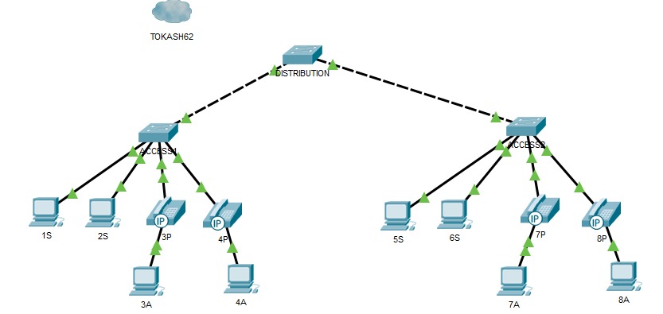

* As the topology is supporting two buildings use the drawing pallet to draw boxes around each building.
  + Click on TOOLS, then DRAWING PALLETTE  
      
    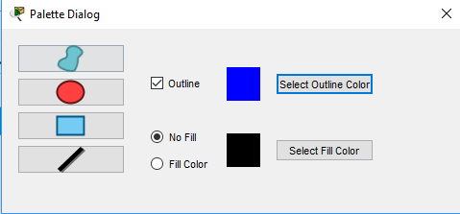
  + Ensure OUTLINE box is checked
  + Select an OUTLINE COLOR of BLUE
  + Click on the blue rectangle
  + You will now be able to draw boxes on the topology, separating the two access nodes
* Click on the ADD A NOTE Icon in the tool bar, and add a note in each box for BUILDING 1 and 2
* Your topology should look like this:

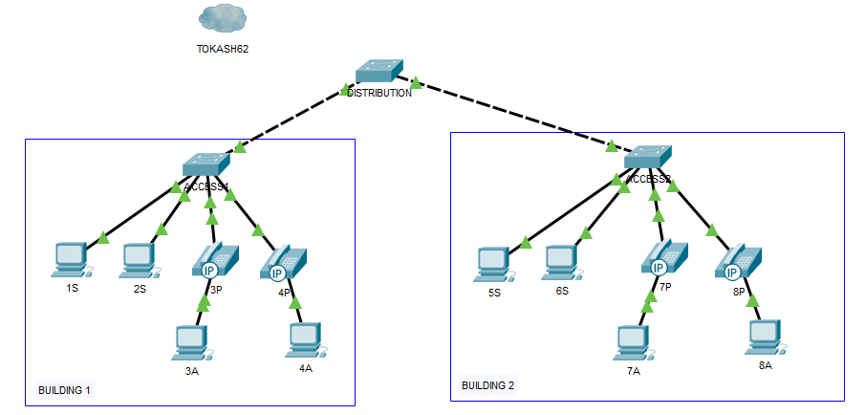

**B - Create the VLANs**Now that we have a working topology lets create three VLANs – one for students, one for administration and one for voice.

* For each switch create VLAN 10, 20 and 150 and name them STUDENTS, ADMINISTRATION and VOICE.
* Implement trunking between the switches.
* Assign all switch ports to the required VLAN. **Also configure the ports connected to an IP phone using a “SWITCHPORT VOICE VLAN 150” command.** After assigning ports on a switch, do a SHOW VLAN to ensure they were set up correctly.
* Create a complex PDU to send a broadcast from PC 1S and ensure it only goes to the student PCs.
* Create a complex PDU to send a broadcast from PC 3A and ensure it only goes to the administration PCs.
* Note: you may have to issue a broadcast from both sides to get full VLAN broadcasting working.

**C – Spanning Tree Protocol**

* Use the SHOW SPANNING-TREE command to find BID’s and spanning tree costs for all three switches. Since there are VLAN’s there will be multiple STP definitions.
* Use the drawing pallet to draw a RED CIRCLE around any that are root switches.
* Open a textbox and answer the following questions:
  + Question 1: What is the full bridge id of the root switch?
  + Question 2. What are the STP costs of the two non-root switches?
* Open another textbox and list the new commands learned in this module.

**D – Lab Completion**

* Save your PKT file : “L5b-*lastname*.PKT”.
* Submit the PKT file in iLearn.